KALA AFGHANA BRIGADE PART 4B … SRM CHANGE … MALAYSIAN VIEW – FAITH vs REASON VIA EXAMPLES

by Harnaak Singh

In Part 4A, in which we moved focus to Malaysia, we discussed three major matters i.e.
- The relationship between FAITH and REASON, LOGIC and CRITICAL THINKING (RLC),
- Showed how Karminder and the Kala Afghana Brigade uses RLC to break down long standing tenets and create new knowledge to replace this,
- Exposed the links between MGC and KARMINDER with the Kala Afghana Brigade and Ideology.
The first dot point FAITH vs RLC is a very important and critical point for us all to understand.
In Part 4A we discussed this with an example of a person crossing the road and then went on the show how Karminder and the Kala Afghana Brigade use RLC to propagate the Kala Afghana Ideology with two examples, one on Sikhi tenets and one on our historical records.
In this part we will look into this with two more examples. The examples show the thought process of the indoctrinated Kala Afghana members.

INTRODUCTION
One of the Kala Afghana Brigade members, Rajinder Singh Sikh made a comment on the article 4A. Article 4A can be viewed at Gurvichar at LINK.
The comment by Rajinder Singh Sikh is shown in Figure 1. The example analyses his thinking of content of the article Part 4A.
Then we look at another example posted in Figure 2 related to LIVING GURU.
For the ensuing discussion remember that Rajinder Singh Sikh’s thinking is hinged on reason, logic and critical thinking (RLC) which is a major Kala Afghana Ideology characteristic.

ANALYSIS – Example 1: Fallacy and Worship
Rajinder Singh Sikh is one of the Kala Afghana Brigade members who has been well indoctrinated.
Figure 1: Comment by Rajinder Singh Sikh
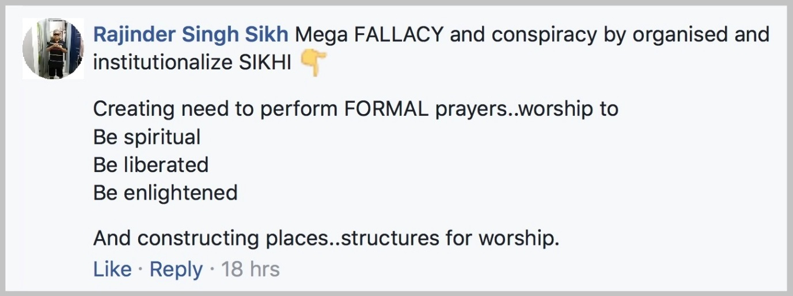

First let us once pen the summary of what was in the article 4A. We discussed three major matters in article 4A i.e.
- The relationship between FAITH and REASON, LOGIC and CRITICAL THINKING (RLC) in the inner-self,
- Showed how Karminder and the Kala Afghana Brigade uses RLC to break down long standing tenets and create new knowledge to replace these,
- Exposed the links between MGC and KARMINDER with the Kala Afghana Brigade and Ideology.
We assume that Rajinder Singh’s comment is directed at the writer of the article.
What is Rajinder Singh Sikh’s opinion of the article. He thinks
- the article is a Mega FALLACY,
- it is a conspiracy by organised and institutionalised Sikhi,
The purpose of this conspiracy is
- to create the need to perform FORMAL prayers; worship to be spiritual, liberated, enlightened, AND
- construct places of worship
We will discuss each of these numbered points in sequence

Point 1: Mega Fallacy
A fallacy is a misconception resulting from incorrect reasoning.
From Rajinder Singh Sikh’s comment it appears that (A), (B) and (C) are all fallacies.
As regards (A) Faith and RLC; the concept was developed over a period of time in the logic series of articles at Gurvichar (a complete set is attached for the Sangat to download). This lead the concept of inner self which is pictorially summarised in Figure 2 below (this was also used in article 4A).
Figure 2: Our inner-self, faith and reason, logic and critical thinking
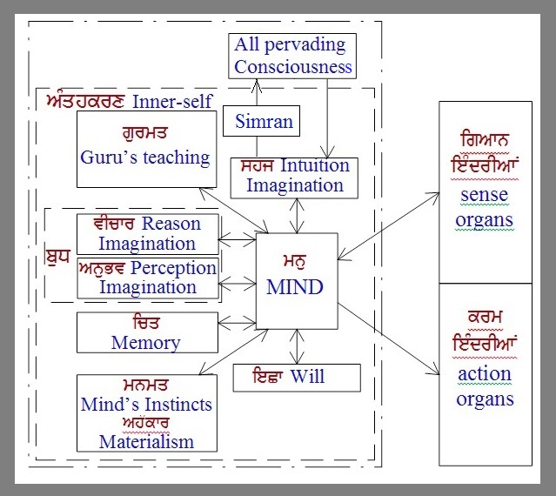
The concept in this figure resulted from a study of physical science, metaphysical science and Gurbani. If our learned Rajinder Singh Sikh is saying this is fallacy then all we can say is GOD HELP HIM.
HOWEVER we can understand why he is making this statement. Since his RLC does not believe in the link to the higher consciousness, then of course the concept shown in Figure 2 is false because he sees it as in Figure 3. He has no FAITH and no DEVOTION i.e. no SHARDA.
Figure 3: Our inner-self, devoid of SHARDA, devotion and faith
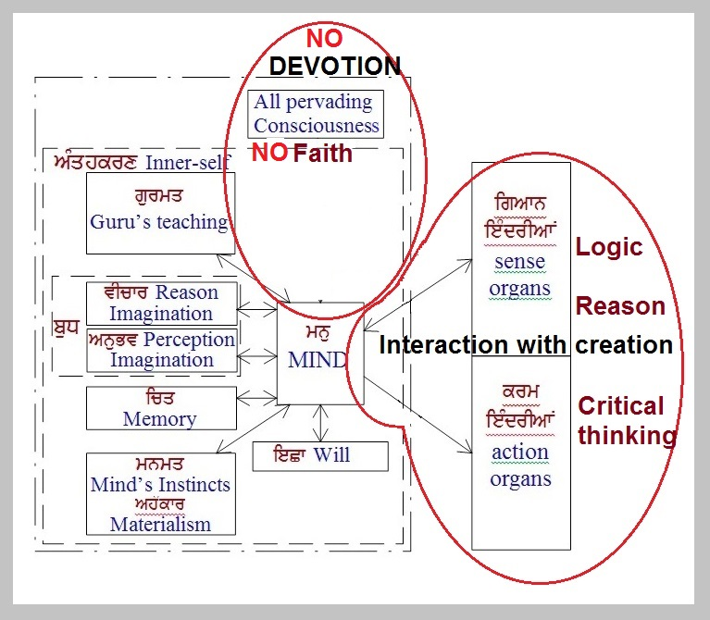
Rajinder Singh Sikh appears to have been indoctrinated to rely totally and exclusively to reason, logic and critical thinking as well as INDOCTRINATED into the Kala Afghana Ideology. His knowledge base is narrowed down to the Kala Afghana Ideology whereby his masters have distorted the TRUE GURMAT (Guru’s teaching). With this limited knowledge he cannot understand Figure 2 and what TRUE Gurmat is. So to his limited mind and knowledge, Figure 2 is a fallacy.
Now one thing that often helps is the intuitive link to the higher consciousness. This link can give us an inkling the something is not right with our thinking. BUT if this intuitive link to the higher consciousness is DEAD, i.e. not there then the person is nothing more than a ROBOT or ZOMBIE, totally controlled by the Kala Afghana Ideology.
As regards (B) and (C), we have presented evidence from documents that originated form the Kala Afghana Brigade members. Again our conclusion in (B) and (C) CANNOT BE FALSE. The same limited knowledge and RLC paranoia of Rajinder Singh Sikh limits him from accepting the FACTS and hence the TRUTH.
He lives in a FALSE Gurmat WORLD, like
- a blind man cannot see light and
- a blind inner-self cannot see the truth.
Both are ruined by REASON, LOGIC and CRITICAL THINKING, being EMPTY of SHARDA, the link to the HIGHER CONSCIOUSNESS GOD.

Point 2: Conspiracy by organised and institutionalised Sikhi
He says that the article is a conspiracy. A conspiracy is a plot to carry out some harmful or illegal act.
What is the illegal act in the article.
Point (A) which is based on physical science, metaphysical science and Gurbani?
Point (B) and (C) which is based on FACTS using the KA member documents?
Come-on Rajinder you could do better than that. Give us some evidence of what you claim.
No evidence? No surprise! Not unexpected of Moorakhs.
Of course there is none because it is a FALLACY that your masters told you. INDOCTRINATION? Your masters can do no wrong!

Points 3 and 4: Need to perform FORMAL worship and build places of worship
This is really WARPED thinking of a confused person. Nowhere in the article Part 4A is there indication of building or propagating a place of worship. NOT in (A), (B) or (C).
My friend, you really seem to be DEEP in the INDOCTRINATION of your MASTERS the Kala Afghana Brigade. You are confused and cannot read and decipher properly. We pity you. God help you.

ANALYSIS – Example 2: Living Guru
Another interesting example from the sagas of Rajinder Singh Sikh worth an analysis is shown in Figure 4.
Figure 4: SGGS Living Guru or a Book (Granth)
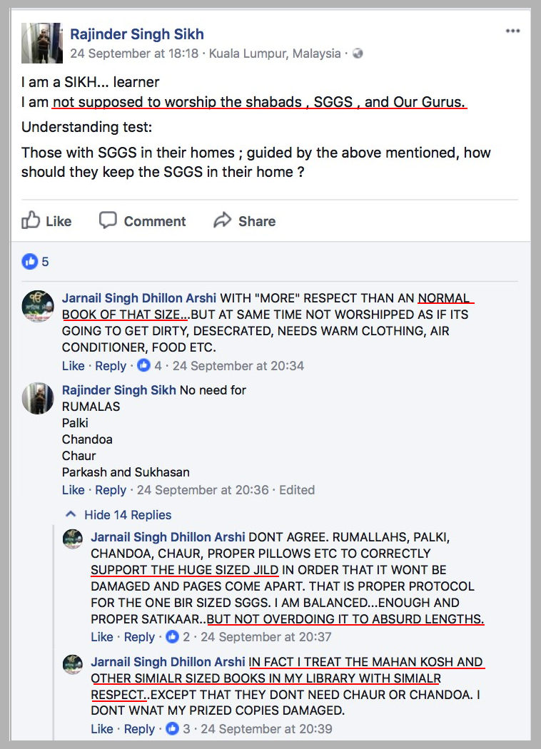

Figure 4 is a discussion between two of the Kala Afghana members about the status of SGGS Ji. Essentially the crux of the discussion is that both these Kala Afghana Ideology suckers don’t believe in the concept of LIVING GURU. They are talking of SGGS Ji as a “BOOK”. They forget what Guru Gobind Singh Ji told us when he edicted us to take SGGS Ji as our GURU. Consider the verse in this dohra we recite every day.
Guru Granth Ji Maaneo, Pargat Guran Di Deh.
BELIEVE (Maaneo) that Guru Granth is LIVING (Pargat) BODY (Deh) of GURUS.
Even while reciting this daily (assuming that they do) these people don’t believe in what the Dohra reminds us day in day out. I shake my head at the EMPTINESS of their inner-self DEVOID OF THE LINK TO THE HIGHER CONSCIOUSNESS.
The explanation of their behaviour lies in the 100% RLC biased thinking, see Figure 3. Based on RLC, HOW CAN A BOOK (more a Granth than a book) be a LIVING ENTITY. Only with SHARDA, the link with the higher consciousness, can one accept SGGS Ji as a LIVING GURU.
I rest my case.

SUM-UP AND CONCLUSION
A blind man cannot see the light. A blind inner-self cannot see truth.
Both are ruined by REASON, LOGIC and CRITICAL THINKING and EMPTINESS of SHARDA the link to the HIGHER CONSCIOUSNESS GOD.
The picture in Figure 3 tells the tale. NO FAITH/NO DEVOTION means NO INTUITION.
What is the impact of this on us. Sangat Ji you can clearly see in the analysis above the thinking and behaviour of the people who operate purely on reason, logic and critical thinking.
We do not want to be ROBOTS or ZOMBIES like them. And our children will be totally run by REASON, LOGIC AND CRITICAL THINKING. They will become LIKE MACHINES, ROBOTS, ZOMBIES.
Our children will lose their capability to INNOVATE and will end up like people were, before our Gurus came along and taught the WISDOM of Gurbani. The future generation will be subservient to their Kala Afghana masters.
PLEASE SANGAT JI, UNDERSTAND the disastrous situation we are putting our FUTURE GENERATION into by getting rid of their intuitive powers.
Exercise of TRUE GURBANI develops intuitive powers. It is this power that makes us RISE TO THE OCCASION.
SANGAT JI, DON'T short change our future generation.
DON'T LISTEN TO THESE MOORAKS who propagate the KALA AFGHANA IDEOLOGY.
Please spend some time to understand the above and also Part 4A and realise what will be lost by losing our SHARDA/INTUITION.
THE ONLY SOURCE OF INTUITIVE POWER IS THE HIGHER CONSCIOUSNESS. This can be developed by TRUE Gurbani teaching.
REASON, LOGIC and CRITICAL THINKING is just a FALLACY, which we falsely think is the solution to FAITH. The two actually are at ODDs.

That’s all for now. We will continue ….
Thank You for reading. ਵਾਹਿਗੁਰੂ ਜੀ ਕਾ ਖਾਲਸਾ ਵਾਹਿਗੁਰੂ ਜੀ ਕੀ ਫਤਹਿ
… to be continued.

Please download the PDF attached and share:

KALA AFGHANA BRIGADE PART 4A … SRM CHANGE … MALAYSIAN VIEW - WHAT KICKED IT OFF

by Harnaak Singh

We discussed briefly the history of the Kala Afghana Brigade from the Global perspective in Part 3. In this part we move to look at the local scene in Malaysia.
This series of articles is to expose to the Sangat that they are being covertly misled. We condemn and expose misleading concepts espoused to the Sangat; this is our RIGHT AS SIKHS OF THE GURU. In the process of exposing these misleading concepts names of those supporting and espousing these will come to the fore. We apologise BUT it is important for the Sangat to know who are those, who profess these misleading concepts, that are against Gurmat, Sikhi tenets and practices. They can then make a learned decision.
Some of us may have realised that we have erred in espousing and supporting these misleading concepts. We know that we are not perfect and can make mistakes and most of all admit them and take responsibility for our actions. We should come out and declare that we have erred. Our Guru and the Sangat is forgiving.
We stress that the Kala Afghana Ideology is an anti-Sikhi and anti-Gurmat ideology. There are a number of organisations as well as many individuals in Malaysia subscribing to this ideology. Of the more prominent ones that appear to follow this ideology, as exposed by Gurvichar, are MGC, Karminder and Autar.
Note: My comments are in green/red italics on specific points within the article.

SRM CHANGE – THE MALAYSIAN SCENARIO
INTRODUCTION
We will now move to the Malaysian scene. Parts 2A and 2B revealed, in the message from Karminder to one of the Kala Afghana Brigade members, the intent to change the Sikh Rehat Maryada (SRM) to meet 100% with the Kala Afghana Ideology. This involves
- UNLEARNING the tenets and practices we follow and RELEARNING the new tenets and practices the Kala Afghana Ideology preaches AND
- building the critical mass support to force the SRM change.
The Kala Afghana Ideology is almost entirely subservient to reason, logic and critical thinking based analysis of the tenets of and practices of the Sikh Faith.
It is therefore important to delve into this and we shall do this first to understand what goes on in these miscreants’ minds.

FAITH AND REASON, LOGIC AND CRITICAL THINKING
The word FAITH, which means “an act or attitude of intellectual assent to the traditional doctrines of one’s religion” itself is at odds with REASON, LOGIC AND CRITICAL THINKING. See Figure 1 which shows this clearly. Faith is related to the All Pervading Higher Consciousness, GOD. Reason, logic and critical thinking is related to our interaction with the creation through our sense and action organs.
Figure 1: Our inner-self, faith and reason/logic/critical thinking
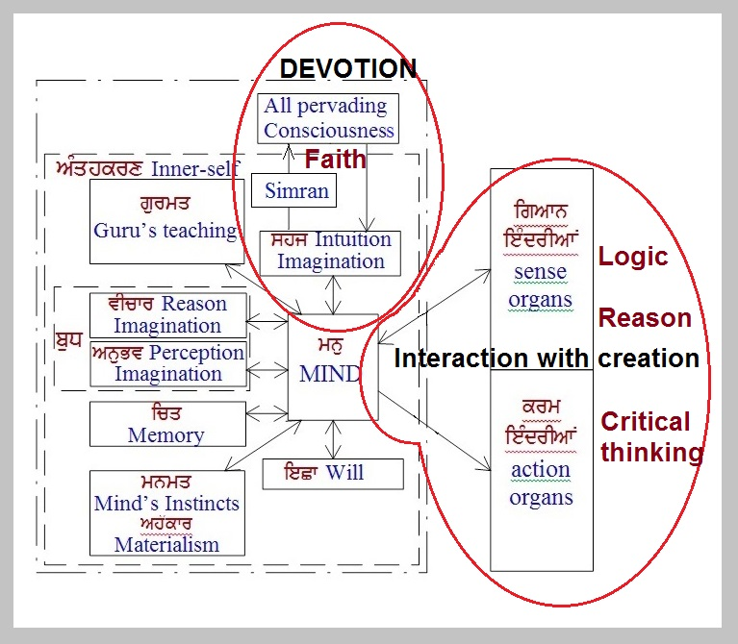
Assent to traditional doctrines means “to accept” the traditional doctrines. It DOES NOT MEAN “to question” traditional doctrines using reason, logic and critical thinking. The traditional doctrines are the tenets and practices of the FAITH, in our case the SIKH FAITH.
“Reason, logic and critical thinking” has an important role to play in our lives. But this role is related to our interaction with the creation (MAYA).
For example if we want to cross the road we make sure that no vehicle will cross our path. From our knowledge we know that we will be injured if this happens. So we reason that if we cross the road while a vehicle is going to cross out path, we will be injured.
Next step in crossing is determining if the approaching vehicle will cross our path. Here is where critical thinking comes in. We make a judgement as to whether the vehicle will cross our path.
Then the logical decision comes in, either cross or let the vehicle pass. If the vehicle is expected to cross our path, we do not cross the road. However if the vehicle is not expected to cross our path we cross the road.
Remember that if we did not have the knowledge and did not acquire it from other sources, we will most surely cross the road and get hurt if a vehicle crosses our path. Then in future we will have that knowledge to make the appropriate decision.
All these activities are related to the sense and action organs. There is no interaction with the Higher Consciousness as show in Figure 1.
However the Higher Consciousness may give us a signal not to cross. This is when we say “I don’t know why but I don’t feel like doing this”. This “feeling” is intuitive and does not originate from our reason, logic or critical thinking.
Putting this into a rule
From our knowledge we REASON out the consequences of an action/activity. We use our CRITICAL THINKING to weigh the factors affecting the action/activity and finally we use our LOGIC to decide on the action/activity to execute.
We have seen how this rule applies to crossing the road.
Now let us see what happens if we can apply this rule to Gurbani and also expose how Karminder and cohorts use this to distort Gurbani. We will look at two cases;
- the question of amrit vela AND
- Guru Nanak’s father was a minister in the court of the King.

The question of Amrit Vela – breaking down long standing tenets
Consider the question “what is amrit vela?” which is the related to activity meditation (simran, Naam Japna).
Figure 2: Meditating at Amrit vela
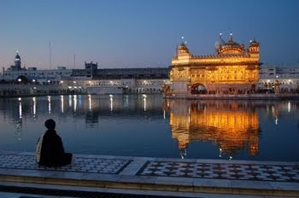
From past practice and from Gurbani, amrit vela is the period of time a few hours before dawn and is the best time for meditation. This is known knowledge from the time of our Gurus and there is nothing to question. We accept this knowledge and act on it.
However if we do not accept what Gurbani and what our long standing practices teach us, i.e. we do not have the FAITH in Gurbani; then we have to create new knowledge to explain the new concept of amrit vela. This is what Karminder and cohorts are doing.
We continue the analysis.
So now, we reject Guru’s knowledge and have to use our own. To create the new knowledge there must be some basis. There being no other source, we have to rely on Gurbani to create this new knowledge.
This is exactly what Karminder and the Kala Afghana Ideologists like Dhunda and others are doing now.
They have to first breakdown the existing knowledge i.e. amrit vela is few hours before dawn by telling us that our long standing knowledge is FALSE. They show this by applying reason, logic and critical thinking that the “accepted definition of amrtit vela is wrong”. For example
- how can amrit vela be in the morning when the thieves and robbers operate at this time?
- how can amrit vela be in the morning when this is naturally the time to be asleep?
Notice how they have cleverly MOVED the timing of an activity
- connected to the devotion link with the Higher Consciousness
- and linked it with our sense and action organs.
AND ask us to UNLEARN what we already know.
Note: This essentially means “to hell with supressing the 5 evils and acquiring the virtures” so to speak; just do what our instincts dictate which is controlled by the 5 evils; be a Manmukh; forget what Gurmat teaches. Further, this also means changing Gurbani to fit the person’s whims and fancies.
Then Karminder and his cohorts create new knowledge, not from our Gurus, but by themselves. Karminder says
- amrit vela is anytime a Sikh chooses (see LINK),
- amrit vela refers to the first phase i.e. early stages of one’s life before childhood i.e. from conception to about 1 year (see LINK). I don’t know what will happen after 1 year. Are we doomed?
Having created this misleading knowledge they want us to RELEARN this new knowledge.

The question that Guru Nanak’s father was a minister – breaking down history
Figure 3: Janaeu ceremony
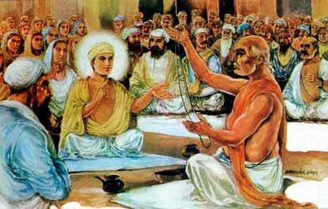
Likewise they do the same with history.
From historical records we know that Mehta Kalu, Guru Nanak’s father was a village patwari (revenue official). We do not question this.
However, Karminder and the Kala Afghana Brigade, using their reason, logic and critical thinking CAP (turban?) question
- how could Mehta Kalu afford to invite the whole village during Guru Nanak’s Janaeu ceremony, when he was only a village patwari (revenue official)? (meaning he would not have enough money to fund the ceremony)
They breakdown the existing history by questioning what we know with reason, logic and critical thinking. Then they create a reason, logical and critical thinking aligned history
- Mehta Kalu was a minister in the court of the King. (so he could afford the ceremony)
This is logically sound but historically FALSE.
Do they mean to say that all the historians who said the Mehta Kalu was a village patwari are fools?
No they are not.
Sangat Ji you should know who are the fools, the moorakhs.

Summing up
In our faith, we have to accept the teaching from our forefathers and follow the tenets Gurbani teaches and accept historical records without question.
Use REASON, LOGIC and CRITICAL thinking in your day to day interaction with the creation NOT the devotional link with the Higher Consciousness, GOD.
We must learn to detect these miscreant elements. The above example shows how they operate. So beware and analyse what they say along similar lines.
This key is
- teaching from our forefathers,
- the long standing tenets and practices Gurbani teaches us and
- our historical records”.

Refer to the following LINK for the main aspects of the Kala Afghana Ideology.

A LITTLE BACKGROUND FIRST
The Sangat may be wondering why and how I got involved in this Kala Afghana “fracas”.
How it all started for me was that I wanted to delve into understanding Jap Ji Sahib. So I started researching for information related to Jap Ji sahib. We will share and discuss this another time when things are better.
It was Dec 2015.
I came across a paper “OMKAR ਓਅੰਕਾਰ The misunderstood word” (see Figure 4).
Figure 4: Paper OMKAR the Misunderstood Word
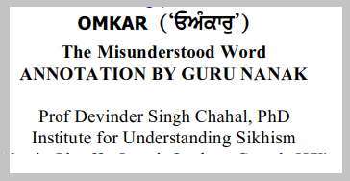
This paper is available at LINK.
I was shocked to read this paper.
The author, miscreant Devinder Chahal, appeared to want to change the pronunciation of ਓਅੰਕਾਰ to Oh Beant. See Figure 5.
I couldn’t believe what I read. And mind you this paper was written in 2005 (TEN YEARS EARLIER).
Figure 5: Ek Oangkar distorted pronunciation (Extract from Chahal’s Jap booklet)
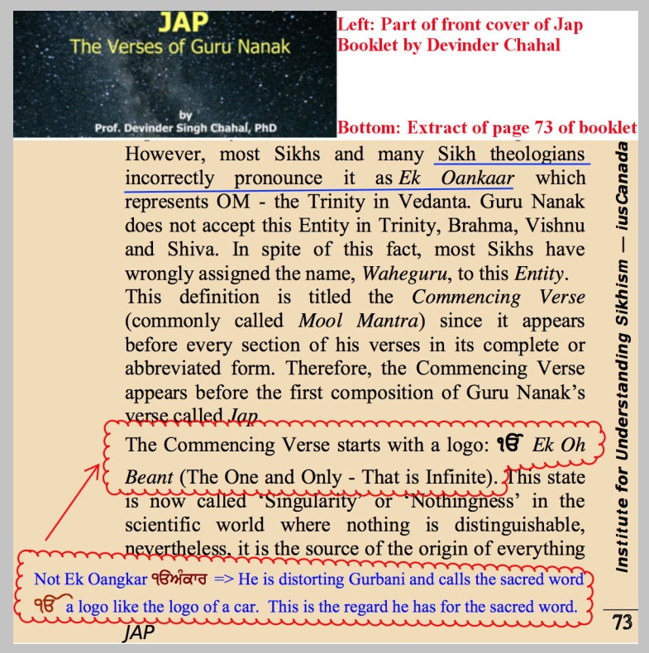
Other points noted in the paper are
- ਓਅੰਕਾਰ Oangkar in banee Dakhni Oangakar has no bearing on ੴ Ek Oangkar
- ਓਅੰਕਾਰ is linked to the Vedas OM and hence Oangkar cannot be the pronunciation and he goes on the give his own distorted view based on the Nanakian Philosophy
- Bhai Gurdas was wrong in giving the pronunciation of Ek Oangkar
- others e.g. Professor Sahib Singh, Dr Trilochan Singh and many others have followed this incorrect pronunciation and also described the history related to banee Dakhni Oangkar incorrectly.
- others e.g. Professor Sahib Singh, Dr Trilochan Singh and many others have misinterpreted banee Dakhni Oangkar and goes on to give his distorted view

I contacted Devinder Chahal in March 2016 with questions on his paper. The correspondence went on until May-2016 but it was like hitting my head on the wall. To give you an idea of how I felt, some of the points in my final email to him are listed below.
- Do not treat Gurbani as an object. It is not an object to be analysed or toyed around with. It is the Creator’s message sent through our Gurus, for us to learn and gain knowledge to practice a truthful living.
- Do not distort the message of Gurbani and our Gurus
- Do not resort to wishy-washy shooting “in the dark” means but provide concrete, logical, scientific and evidence based reasoning to justify your claims
- Learn to accept that you are not perfect and can make mistakes and most of all admit them and take responsibility for your actions.

Then I also corresponded with Hardev Singh Shergill editor of the Sikh Bulletin on his belief that
- Guru Nanak preached DEISM and that Guru Nanak did not believe in God
AND also Colonel Manmohan Scout on
- Guru Nanak preached DEISM and God does not have any control over the creation
in May and June 2016.
The outcome was similar that with Chahal except that there were a number of people giving support to them. To share one of my final words to them about the God they espouse were
- A dead God leaving behind its agent nature (which is actually Maya which Gurbani teaches we have to overcome – more like satan in control) and a magical “energy” to do the job.

Both Devinder Chahal and Manmohan Scout have produced distorted English version of JapJi Sahib based on the philosophy they follow.
The correspondence was to no avail. They were not prepared to accept the distortion of Gurbani they were propagating.

Figure 6: Kala Afghana and associates
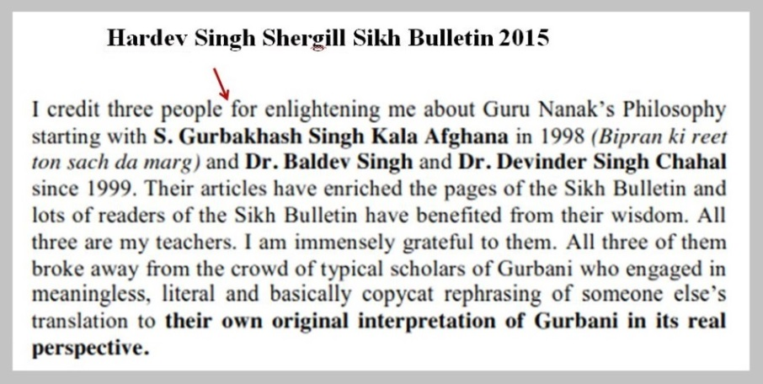
Further probing revealed that these people were with the Kala Afghana Brigade aligned to the Kala Afghana Ideology (see Figure 6). They covertly and falsely call this ideology “Guru Nanak’s Philosophy”. Actually their “Guru Nanak’s Philosophy” which they also term “Nanakian Philosophy” is a distortion of Gurbani to fit into their agenda.

Figure 7: Forward by Karminder in Chahal’s Jap booklet
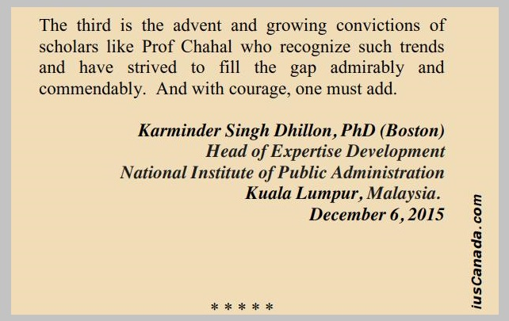

In April 2016, Devinder Chahal sent me his English version of Jap Ji Sahib. To my surprise I found that the foreword to Devinder Chahal’s Jap Booklet was written by non-other than the Malaysian Fake Guru Karminder. This close association of Karminder with Chahal links Karminder to the Kala Afghana Ideology (see Figure 7).
Figure 8: Presentation by Chahal and Manmohan at GSC conference March 2017
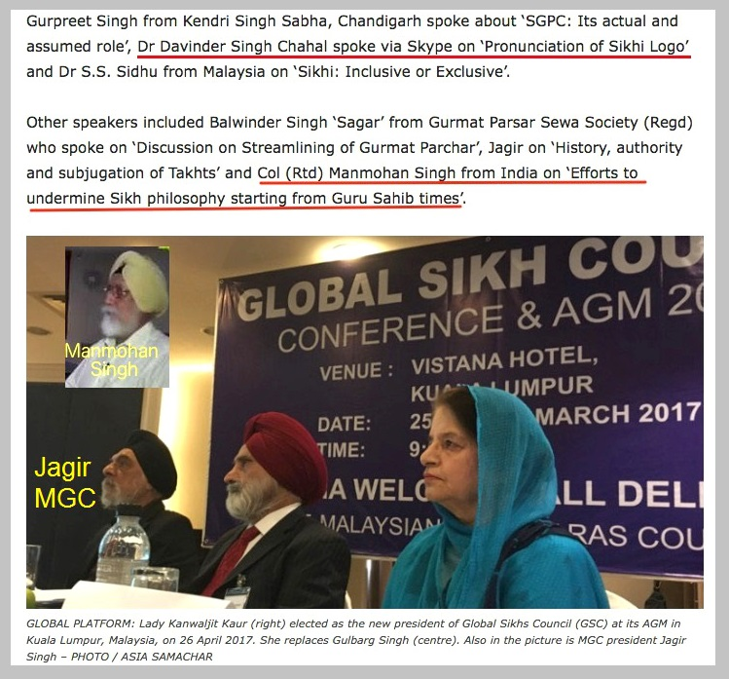
Please note that both DEVINDER CHAHAL and MANMOHAN SCOUT made presentations at the GLOBAL SIKH COUNCIL meeting in KUALA LUMPUR in March 2017. This meeting was organised and sponsored by the MGC.
This links MGC to the Kala Afghana Brigade and Ideology.

CONCLUSION
FAITH is actually at odds with REASON, LOGIC AND CRITICAL THINKING.
In our faith, we have to accept the teaching from our forefathers and follow the tenets Gurbani teaches and accept historical records without question.
They ask us to UNLEARN what we know and to RELEARN the new knowledge based on Kala Afghana Ideology. We should reject this.

We have to be careful when they talk about reason, logic and critical thinking. We can and should use REASON, LOGIC and CRITICAL thinking in our day to day interaction with the creation BUT definitely NOT for the devotional link with the Higher Consciousness, GOD.
The Kala Afghan Ideology rejects the pronunciation of Ek Oangkar. They state that Guru Nanak was a DEIST and did not believe in GOD. Do we want to follow this anti-Sikh and anti-Gurmat ideology?
Devinder Chahal and Manmohan Scout who are aligned with the Kala Afghana Ideology, presented at the MGC sponsored Global Sikh Council Inc in Kuala Lumpur in March 2017. This clearly shows that MGC supports the anti-Sikh and anti-Gurmat Kala Afghana Ideology
Without doubt Karminder and the MGC are linked to the Kala Afghana Ideology.
We will continue and start to unravel the Malaysian Kala Afghana world in the next parts.

That’s all for now. We will continue ….
Thank You for reading. ਵਾਹਿਗੁਰੂ ਜੀ ਕਾ ਖਾਲਸਾ ਵਾਹਿਗੁਰੂ ਜੀ ਕੀ ਫਤਹਿ
… to be continued.

Please download the PDF attached and share:

KALA AFGHANA BRIGADE PART 3 … SRM CHANGE … HOW IT STARTED - GLOBAL VIEW
by Harnaak Singh
We analysed part of the ideology of the Fake Guru Karminder in Part 2A and 2B outlined in his message to one of his Kala Afghana Brigade members.
Now we will move to how the Kala Afghana anti-Sikhi anti-Gurmat ideology of the Fake Self-made Guru Karminder subscribes to was born and the process up to now.
THIS IS A MUST READ. PLEASE DO NOT MISS ANY PART. PLEASE SHARE THE PDF ATTACHED.

SRM CHANGE – THE GLOBAL SCENARIO
Let us discuss a scenario related to this issue of change of SRM. This is a scenario built from the observation and references related to the Kala Afghana Brigade which started from late 1990s. One important reference is Roger Ballard in the article “The Oxford Handbook of Sikh Studies: Reflections on the current State of Play in an Emergent Discipline” (Center for Applied South Asian Studies online article see LINK A).

LONG TIME HISTORY AND THE PANTH
The Panth - Diversity
Let first consider the word “PANTH”. The word “PANTH” generally means a way, a religious order, essentially a path one follows.
Broadly “panth” in SGGS Ji means those who abide by the teachings of Guru, which are essentially words from God. The key in these is to overcome the 5 evils or vices and the remembrance of God as well as the acceptance of a unitary God, the creator of the whole creation with the collective power of creating, preserving and destroying. See Figure 1.
Figure 1: Evils and Virtures
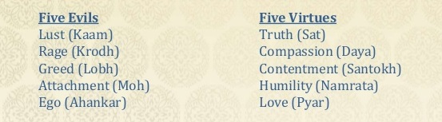
Similarly Guru Gobind Singh Ji in Dasam Granth (DG), e.g. DG Panaa 136 Stanza 29 (ref. searchgurbani.com) says the role is to induct people to the righteous path and stop them from evil actions (again the 5 evils refer here). This is the panth of all mankind that follows the righteous path.
In our scriptures the members of this panth, commonly termed ‘Gurmukh’ in the SGGS Ji, are those who have sanctioned the 5 virtues (i.e. rid themselves of the 5 evils). In the DG the five evils are well expounded for example in Tav Prasad Sawaeeyay these are explained with examples, while Chaupaee is the supplication to God to protect one from the 5 evils.
THEREFORE THE CORE BELIEF IS FOLLOWING THE RIGHTEOUS PATH BY OVERCOMING THE FIVE EVILS, ACQUIRING THE FIVE VIRTUES AND REMEMBRANCE OF AND DEVOTION TO GOD.
Let us divert a little.
Different faiths set up ‘orders’ with this core belief.
Why ‘orders’?
The ‘order’ is a group with set of rules and regulations i.e. path that its members follow to realise the core belief.
Why path? Look at the picture in Figure 2.
Figure 2: No Path or Path
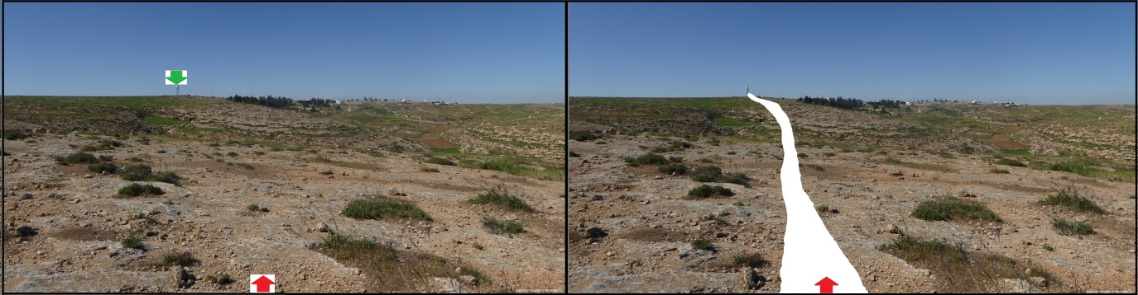
First look at the left frame. We are at the red arrow and the destination is the green arrow. In left frame we will have to find our way to get to the destination. We cannot see the destination. All we know is we have to go sort of straight ahead and that there is a green arrow at destination. There are rocks, shrubs, pond, soft ground and other obstacles along the way. It would be a difficult task to get to the destination. It will have to be by trial and error and we may falter many times.
Now if someone earlier, has surveyed the place, made a path, then it would be an easy task to get to the destination. This is shown in the right hand frame of Figure 2, then all we have to do is to follow the path and will get to the destination.
See. How easy it becomes to follow the path.
The rules and regulations or the ‘order’ are the path. This is the case with every ‘order’ or faith. There are tenets and practices which provide the path. We follow these tenets and practices and we get to the end, which is commonly term liberation or salvation or mukti ਮੁਕਤੀ.
Likewise in Sikhi.
Guru Nanak Dev Ji started the faith. He recorded his enlightened knowledge, which was from God, and this continued with the second, third up the tenth Guru, each Guru adding the received enlightened knowledge (Figure 3).
Figure 3: Ten Gurus – Guru Nanak Dev, Guru Angad Dev, Guru Amar Das, Guru
Ram Das, Guru Arjan Dev (top L to R); Guru Har Gobind, Guru Har Rai, Guru Har Krishan, Guru Teg Bahadur, Guru Gobind Singh (bottom L to R)
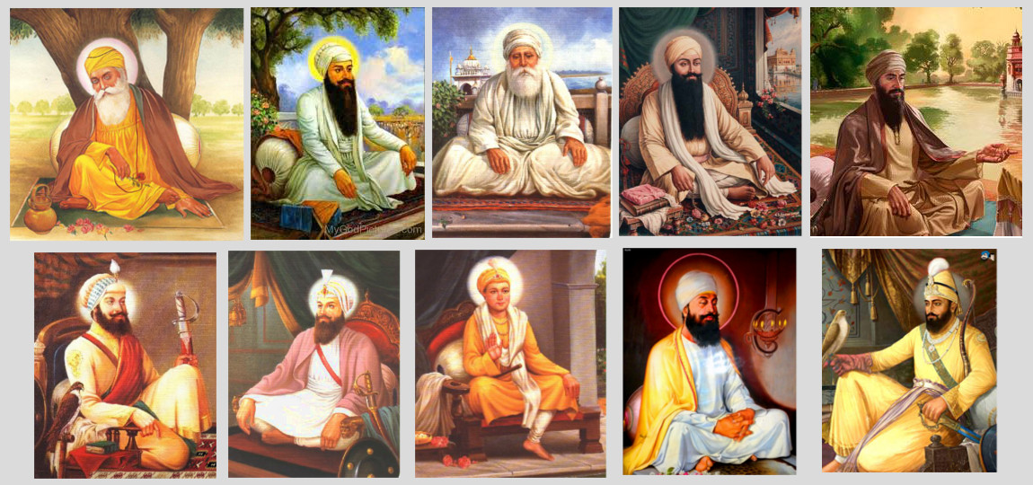
This knowledge set out the tenets of the Sikh faith. Rehatnamas outlined the practices of the faith. There were different Rehatnamas by different groups but by and large they followed the core tenets set out by our Gurus. We shall not go into detail but to indicate that the sum of all these is the panth that is made up of diverse groups with the same destination (goal).
Now let’s look at the next level of panth. Within the Sikh Panth there are a number of panths (sort of sub-panths). For example there are Taksali Sikhs, Nihang Sikhs, Sikhs who follow the Akhand Kirtanias, Sikhs who follow the Sant Deras and Sikhs who follow the Akaal Takhat sanctioned Sikh Rehat Maryada as well as Sehajdhari Sikhs.
Figure 4: SGGS Ji, Dasam Granth, Vaaran Bhai Gurdas and Ghazal Bhai Nand Lal (L to R)
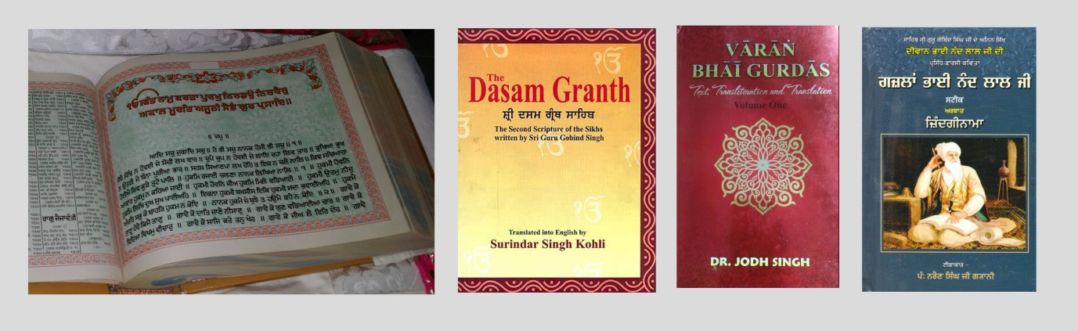
They can collectively be seen as sort of “a panth” since there are variations in their paths, though, by and large they follow the teachings in the SGGS Ji and Dasam Granth with reference to compositions of Bhai Gurdas and Bhai Nand Lal plus other reference and historical records and documents (Figure 4). With their core belief being
FOLLOWING THE RIGHTEOUS PATH BY OVERCOMING THE FIVE EVILS, ACQUIRING THE FIVE VIRTUES AND REMEMBRANCE OF AND DEVOTION TO GOD.
They have co-existed in this diverse from for hundreds of years while following their slightly different Maryadas productively.
This is what has been handed down from our forefathers and what we refer to when we say the Sikhi tenets and practices from our Gurus times brought down by our forefathers.
The Taksalis and Santh Deras plus individual Kathakars/Kirtanias have played a significant role in propagation of the faith drawing “successive generations of Sikhs into religious commitment, spiritual vitality and community services” as Roger Ballad puts it.
In fact Roger Ballard in his article highlights that this diversity that existed cordially, albeit with minor differences, for a long time.
Note that there were attacks on Sikhi from the time of our Gurus by various groups e.g. the Minas, Handalyias, Ram Raias, Pasaurias, Bekhi Sikhs etc. We will ignore this part of history for brevity.
Let us continue to the period of mid-eighties.

DELVING INTO HISTORY - NORTH AMERICAN SCENE
Threat to Diversity and Philosophy
Roger Ballard goes on to state that this unity was disrupted by the Indian Army assault on the Akaal Takhat (Figure 5).
Figure 5: Akaal Takhat – before and after damage (L to R)
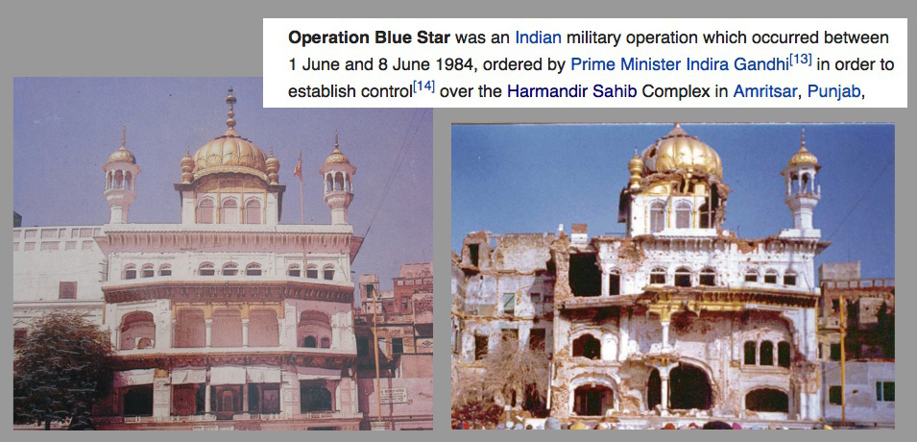
This resulted in the rise of Sikh Studies in North America, with the majority of those being from the academic field. Accentuating this was the arrival of Sikhs from India, students who sought refuge in North America. They became strong Sikh Nationalists.
Another contributing factor could be the Sant Deras. These were well proliferated in North America (and also the rest of the world). Though most of them were genuine there were some who may have taken advantage and hurt some local Sikhs. These disillusioned Sikhs banded together with the Sikh Nationalists. This resulted in a largely POLITICAL AGENDA DRIVEN MOTIVE, in association with some of the scholars. Unfortunately these energies were directed towards the tenets and practices of the Sikh faith instead for looking at political avvenues. One of their main points of focus was the Vedic references in the Sikh faith Granths and associated literature.
This is leading towards an “ideological rejection of the empirical existence of plurality” within the Sikh Panth i.e. a single panth thinking, the EK-Panth concept. THIS POLITICALLY MOTIVATED DIRECTION in the words of Roger Ballard “THREATENS TO OVERWHELM THE CONCEPTUAL AND METAPHYSICAL FOUNDATION OF THE PANTH”. There appears to be efforts to demonstrate “Sikh Philosophy as a unique feature of the Qaum”. This came to the fore around mid to late 1990s.
Figure 6: Kala Afghana Brigade (some of them)
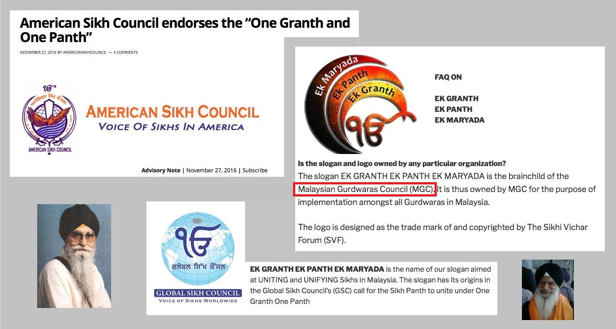
It is believed that it is at this point that Kala Afghana came to the scene. He spent some years in California and then his books Bipran Ki Reet started appearing and this was the start of controversies. He may have derived his inspiration from the Bekhi Sikhs and Pasaurias who had attacked the Sikh tenets previously and was also helped by those intellectuals/ disillusioned Sikhs. This lead to the EK-Granth concept, which was espoused first by a North American Sikh organisation. Global Sikh Council, Malaysian Gurdwara Council, amongst others, also became very strong supporters. Many other individuals, Ragi Darshan being a prominent one, are also involved. These are the Kala Afghana Brigade (see Figure 6). Please see LINK B for more information.
Figure 7: Nanakian Philosophy
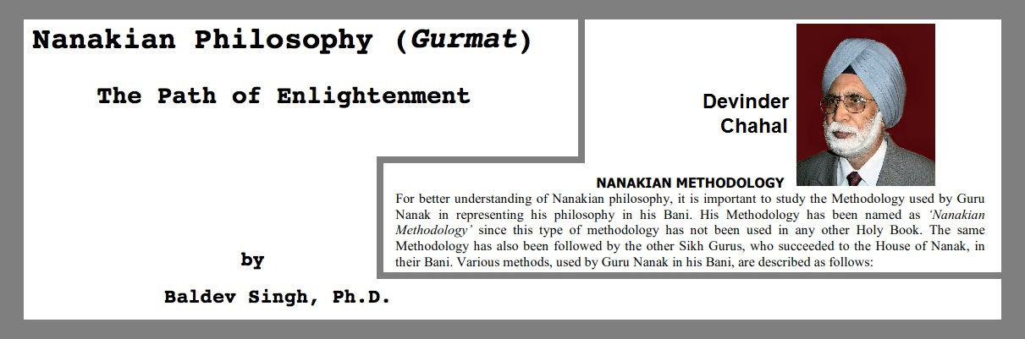
It becomes apparent from Roger Ballad’s paper that this very likely lead to the emergence of e.g. THE “NANAKIAN PHILOSOPHY” (by Dr Baldev Singh and Dr Chahal) (Figure 7), AN EXTREME INTERPRETATION of SRI GURU GRANTH SAHIB JI in such a manner AS TO TOTALLY ABSOLVE it of any VEDIC INFLUENCE.
This was during the period end 1990 to early 2000.
Figure 8: Some of the Kala Afghana Ideology propaganda machine
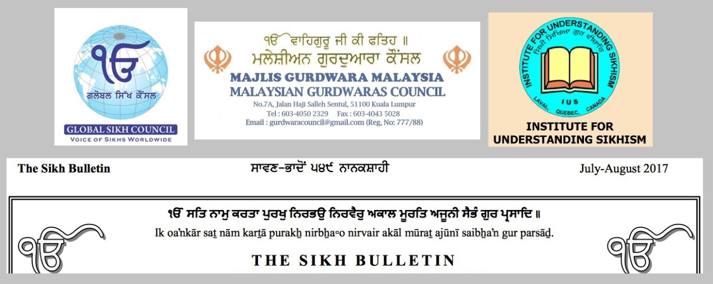
The Sikh Bulletin, Institute of Understanding Sikhism, Global Sikh Council Inc., Malaysian Gurdwaras Council and the ‘Missionaries’ are some of the more apparent propaganda machine for this ideology (see Figure 8). Many others including individuals, Ragi Darshan being a prominent one, are also involved. Please see LINK B for some further information.
The concept espoused is what we call the Kala Afghana Ideology and the people propagating this view, the Kala Afghana Brigade.

What will and is happening
To implement this Kala Afghana ideology, there is a need to firstly REMOVE ANY HURDLES in the way. Non complying SIKH TENETS AND PRACTICES handed down by our forefathers will have to be ELIMINATED. Anyone, e.g. Sant Deras, Baba Banta Singh and others, who propagate these practices and tenets, will be denigrated, degraded, demeaned, threatened with the aim that they comply with the Kala Afghana Ideology. See Figure 9.
Figure 9: Some of the parcharaks who do not subscribe to the Kala Afghana Ideology
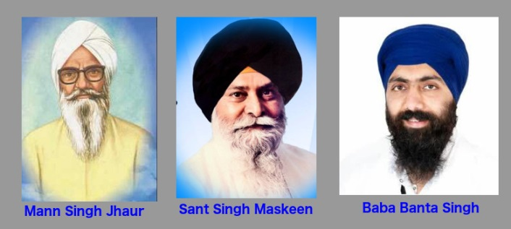
Works (mainly videos) of older credible preachers like Sant Singh Maskeen, Man Singh Jhaur and many others befall the same fate (Figure 9).
There is a need to project only the EK GRANTH concept (Figure 10) whence all other spiritual parmanic texts, the Dasam Granth, Vaaran Bhai Gurdas, compilations by Bhai Nand Lal plus other supporting literature that are used as reference to understand Gurbani, NEED TO BE SIDELINED. Why sidelined? Because they are thought to be influenced by Vedic thought.
Figure 10: The Ek Granth Ek Panth Ek Maryada concept
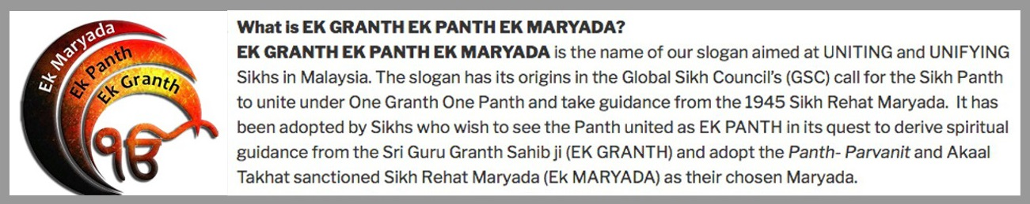
The Ek GRANT concept is being promoted as a uniting and unifying concept. However it has been seen that this Kala Afghana ideology concept seems to cause division more so than unification.
The first step of the Kala Afghana Brigade target is Dasam Granth composed by Guru Gobind Singh Ji. How to do this?
Can’t say the Guru Gobind Singh Ji was influenced by Vedic thought and reject Guru Gobind Singh Ji.
So, what else?
Figure 11: Fabricating history against Dasam Granth
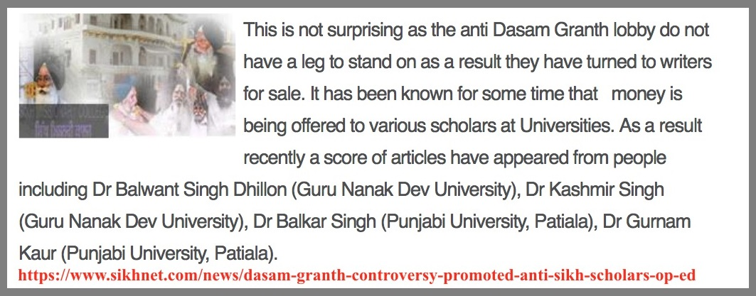
Get people to write made up documents and by other degrading means show that Dasam Granth is not composed by Guru Gobind Singh Ji and then get the Sangat to reject the Dasam Granth (Figure 11). Once this step is successful then go for the other texts.
Figure 12: Distorting Dasam Granth and History.
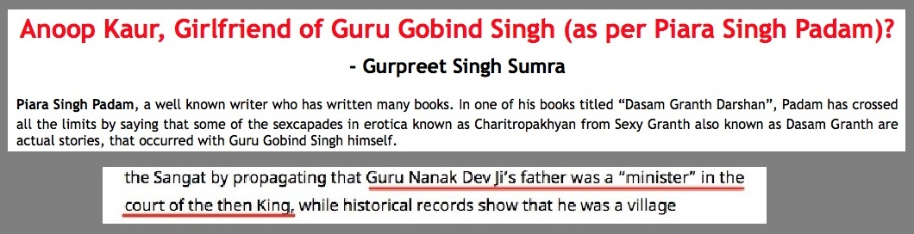
There is also a need to REWRITE SIKH HISTORY to further breakdown any link to VEDIC INFLUENCE (Figure 12). It is claimed that the writers of these literature were influenced by Vedic Philosophy and hence the literature has to be DISCARDED.
It is also our belief that once this, i.e. the removal of spiritual texts and reference literature, is achieved, the SGGS Ji will be reinterpreted to absolve it of all reference to Vedic Philosophy.
How this will be achieved is still not clear, a possibility is the removal of these references from the SGGS Ji. However early directions on this have emerged (Figure 13).
Figure 13: Distorting Sri Guru Granth Sahib Ji
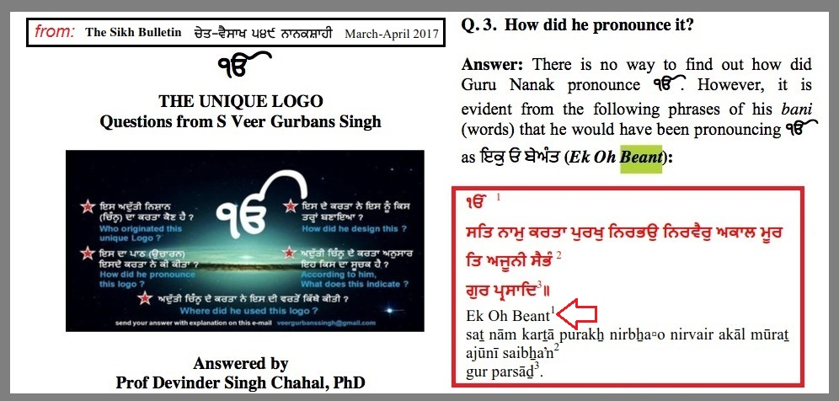
The Nanakian Philosophy may provide the direction. It is noticed in one of the methods observed of late, is to distort Gurbani by reinterpreting conflicting parts in a manner such that that part only applies to our soul.
Figure 14: Distorting Gurbani – Gurbani rejects rebirth
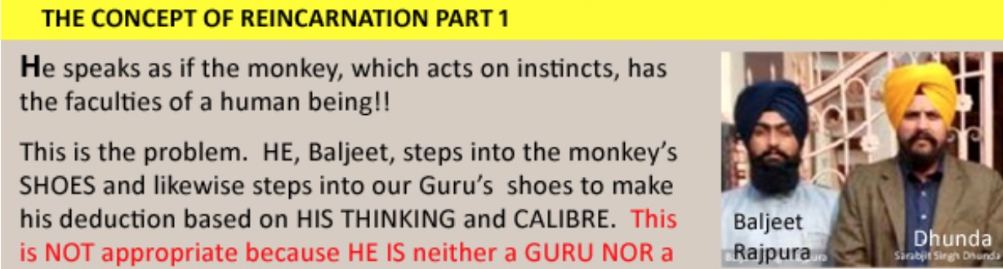
For example they interpret ‘death’ and ‘rebirth’ to mean ‘death and rebirth of the soul’ which occurs time and again during one’s lifetime (Figure 14). In this manner the references to Mythological characters and the story and message behind the reference is totally ignored. It appears the Kala Afghana preacher has a free run in the interpretation of Gurbani. However the Nanakian Philosophy is possibly used as a resource.
Figure 15: Unlearning and relearning to distort Gurbani by a Kala Afghana convert
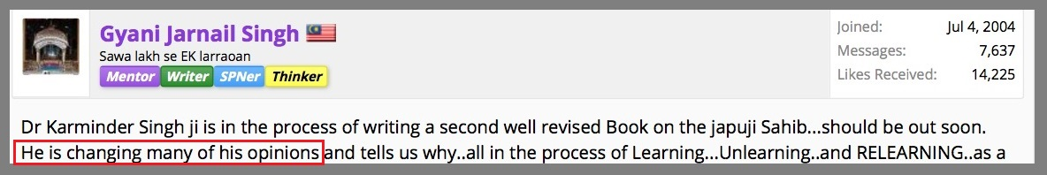
All this involves unlearning what was, and relearning what is in line with the Kala Afghana agenda (Figure 15). Once this relearning is accomplished the Ek Granth will be the result.
By this time the CRITICAL MASS will be achieved. Then the Sikh Rehat Maryada would be changed and EK-Maryada will then eventuate. This will lead to the Ek Panth.

CONCLUSION
We have briefly reviewed how history moulded the scheme of things that have emerged. The Sikh Panth was diverse, all abiding by the teachings in the SGGS Ji and Dasam Granth with reference to compositions of Bhai Gurdas and Bhai Nand Lal plus other reference and historical records and documents.
The scene changed after 1984 to promote “Sikh Nationalism”. The main impetus to this was the attack on the Golden Temple and some Sikhs who had been taken advantage of by the Sant Deras.
This lead to what we call the Kala Afghana Ideology the core of which is the Ek Granth and possibly Nanakian Philosophy. This involves the removal of non-complying Sikhi tenets and practices as well as reinterpreting Gurbani. Sikhi is to be sanitised of any Vedic influence/references. Remember all these do not have any historical basis or supporting records. Only ‘logic, reason and critical thinking’ is the basis for their interpretation of Gurbani tenets and practices.
The Ek Granth will be then achieved. This will be followed by Ek Maryada. Also necessary is sanitisation of all those who resist by various means. Once critical mass is reached by changing the SRM to meet with the Kala Afghana Ideology, Ek Panth will automatically follow.
The next step is to look at the local scenario in Malaysia.
That’s all for now. We will continue ….
Thank You for reading. ਵਾਹਿਗੁਰੂ ਜੀ ਕਾ ਖਾਲਸਾ ਵਾਹਿਗੁਰੂ ਜੀ ਕੀ ਫਤਹ
… to be continued.

PLEASE SHARE

